Are You Using Safe Cookware?

Did you know that the cookware you use could be leaching toxins into your food? Well, it’s true. Colored Vintage Tupperware contains lead, arsenic, mercury, and cadmium. Cookware can last you a lifetime, but it can be a problem for your health. That’s why it’s important to use safe cookware.

Cast Iron
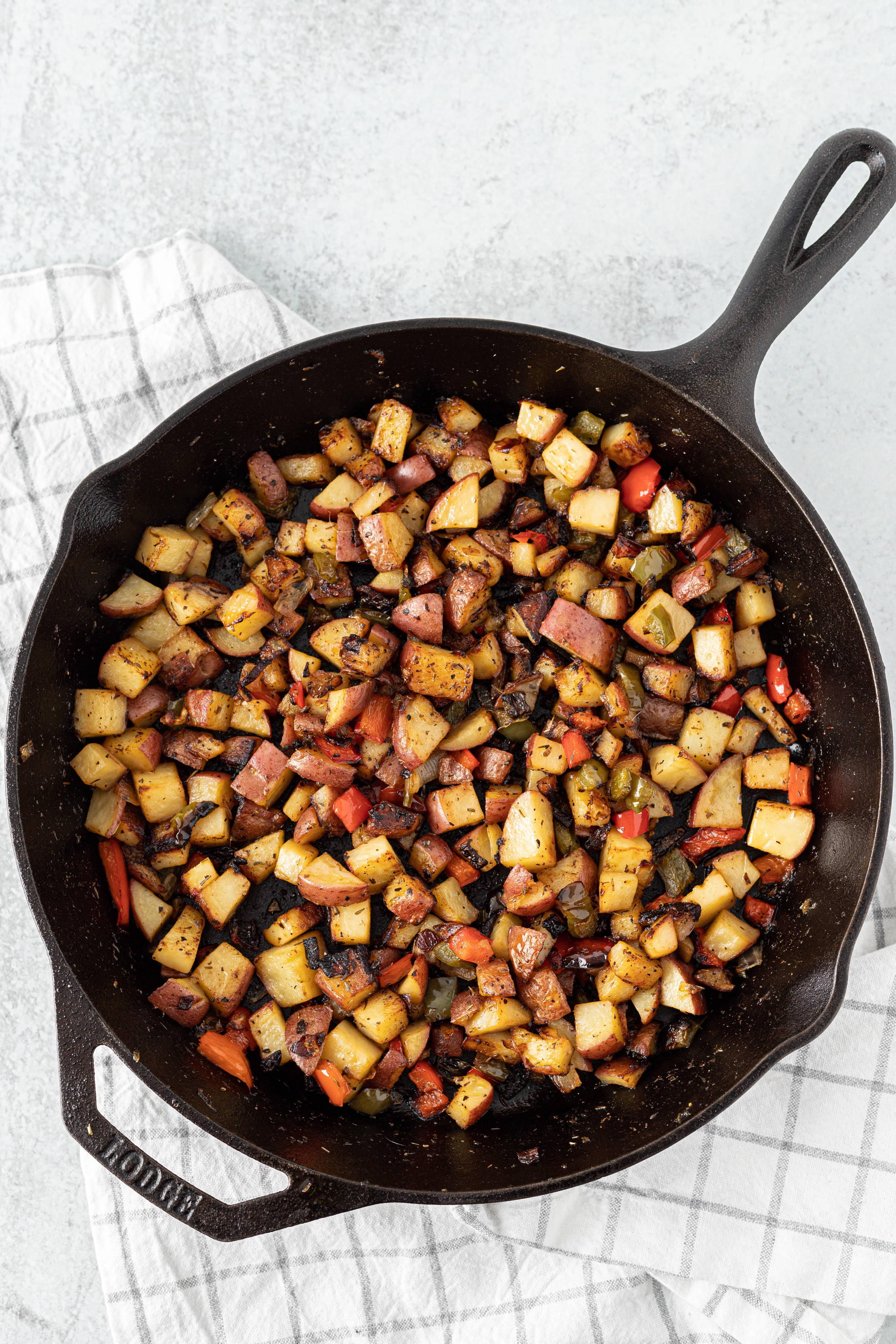
- Good source of iron
- If you have an issue with high iron, beware of cooking acidic foods because it can release more iron into the food.
- Examples of brands: Lodge, Le Creuset, Staub, Smithey Ironware Company
- Care Instructions
  - Season your cast iron pan when you first get it
  - Clean your pan after each use by using soap and water
  - Re-season your pan
  - Fry and sear in your pan to improve the seasoning
  - Always dry your pan after cleaning

Stainless Steel
- Make sure to purchase quality to get the safest
- Contains a mixture of metals, such as chromium, molybdenum, titanium, and nickel
- Poor heat conductor by itself which is why aluminum and copper are included as core metals for heat conductivity
- Needs a small amount of fat to be non-stick
  - Trick: Heat the pan until the fat melts and runs in streaks when tilted and then leave food cooking until it releases by itself or is easily lifted
- Cookware grading system
  - 200 Series SS – Avoid due to heavy metal leaching
  - 300 series SS-304 and 316
  - 400 series SS-430
    - Magnetic nickel-free, surgical grade best
    - Durable and easy to clean
  - 300-400 series – Will not corrode or weaken with cooking acidic foods
- Examples of trusted brands: All-Clad (US) 18/10 (Cr/Ni), Cusibox 18/8 (Cr/Ni), 360 Cookware (US) surgical grade with aluminum core, Homichef-nickel free stainless, and Maxam-surgical grade stainless

Glass
- Does not alter food
- Kosher
- Inexpensive
- Example of brands: Pyrex and Anchor Hockings

Ceramics
- Make sure to purchase quality to get the safest
- Caution: Ceramic glazes may contain lead
- Examples of safe brands: GreenPan, Our Place, Caraway Cookware, and Xtrema

Enameled
- Enamel material is a type of glass.
- Example: Le Creuset (cast iron with porcelain enamel coating on the inside)

Crockpots
- Make sure to do your research because new non-toxic options are becoming more available
- Some heavy metals are used in manufacturing.
  - Lead is used in the glaze, non-stick coatings, plastic pieces, and paints.
  - Cadmium is used in the glaze.
- Beware of crockpot liners that may contain harmful BPA plastics, especially of concern due to heating
- Look for a certified lead-free glazed crockpot
  - If you are in California, look for Prop 65 label which indicates a very low leaching of lead.
- You can purchase a ceramic free slow cooker that has a glass liner.
  - Examples: VitaClay and Cuisinart Lead-Free Slow Cooker

Copper
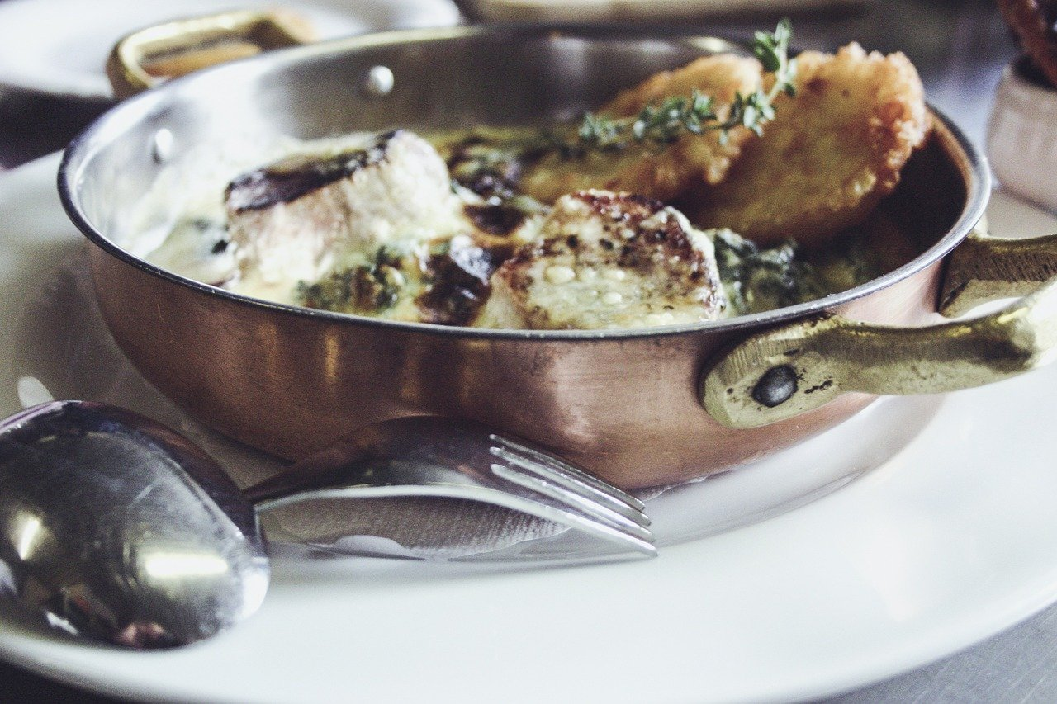
- Oldest metal used by man
- Boasts unrivaled conductivity
- Heats quickly and evenly and then cools
- Stabilizes eggs whites and preserves the green color of vegetables
- Off flavors can occur because copper reacts with acid – which can become toxic in excessive amounts
- Do not use copper to cook sauces with ingredients like lemon juice
- Most copper pots and pans need to be lined for everyday cooking
  - Example: French Chef’s Line with Tin or stainless steel (safest lining for copper cookware)

Other Tips and Tricks to Minimize Toxins in Food
- Use filtered water in cooking
- Handwash cast iron, stainless steel, and ceramic cookware
- Use decorative china and colored pottery as décor instead of with food
- Avoid using liners in roasting pans or crock pots
- Use high quality stainless steel or cast-iron pans when cooking at high temperatures
- Use lower heat in crock pots due to higher temperatures increasing metal leaching
- Use wooden spoons and spatulas against metal when cooking to avoid scratching or
- Do not use any cookware or dishes with cracks

Karen Marschel, RDN LD CDCES
www.kmnutrition.com
320.267.0053

